CSC8635: Machine Learning with Project -  
Extended Technical Project

Submitted By- Parth Sagar

210431117

Part 2A

Context: Distracted driver detection is now becoming a really important need for safe driving as each year the accident cases are exponentially rising and distraction towards another activity is increasing.  
Objective: The objective is to make a CNN model which correctly classifies the class and the driver’s distraction so that in the future it can be combined to alert system to avoid accidents.

Method: A 6-layer model with 16X16 filter is used to extract the features. A diamond shape approach has been taken where first features are extracted and split for models understanding the after the model gets the details the nodes are converged. The input shape value has been taken as 160X160 pixels as that uses the maximum capacity of RAM.

Results: The accuracy achieved here is more than 90 % to verify it isn’t overfitting 10 images from the test folder provided were predicted out of which 9 were predicted accurately hence verifying the results. Rest of the transfer learning models failed due to overfitting.

Novelty: 2 different types of train test split models were used and all models were tested in these 2 conditions. Which led to very distinct results so the verification required some manual touch. The novel model I have designed has been tested with layer counts from 1 to 10 and hyperparameters changing for all of them. The novel approach used here was achieved by the latest Activation function (**swish)** which was launched by google and they hold a patent for it. Any previous works haven’t included this activation function.

Part 2-B:



Fig 1. Accuracy comparison model

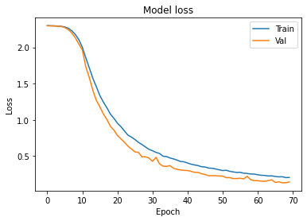 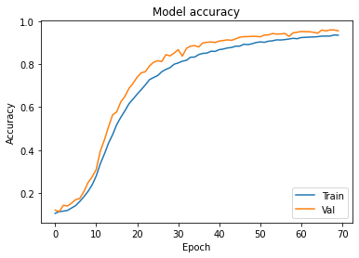

Fig. 2 Accuracy and loss graph for CNN 6 layer model